IMAGE TRANSMISSION BASED OFDM CHANNEL ESTIMATION OVER DWT BASED CARRIER MODULATION TECHNIQUE

A PROJECT REPORT
Submitted by
L H Prajwal [RA2211004020161]
B Abhinandhan [RA2211004020170]
K Sumadhar [RA2211004020173]
Gutta Tharun [RA2211004020198]

Under the guidance of
Dr. A. Mohan Babu
(Assistant Professor, Department of Electronics and Communication & Engineering)

In partial fulfillment for the award of the degree of

BACHELOR OF TECHNOLOGY
in
ELECTRONICS AND COMMUNICATION ENGINEERING
of
FACULTY OF ENGINEERING AND TECHNOLOGY



SRM INSTITUTE OF SCIENCE AND TECHNOLOGY RAMAPURAM
MAY 2026

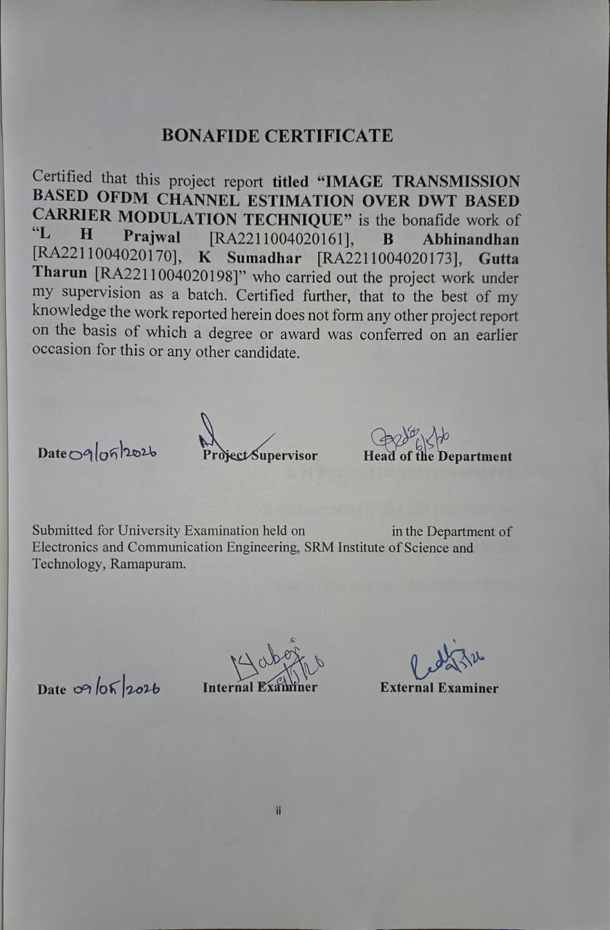

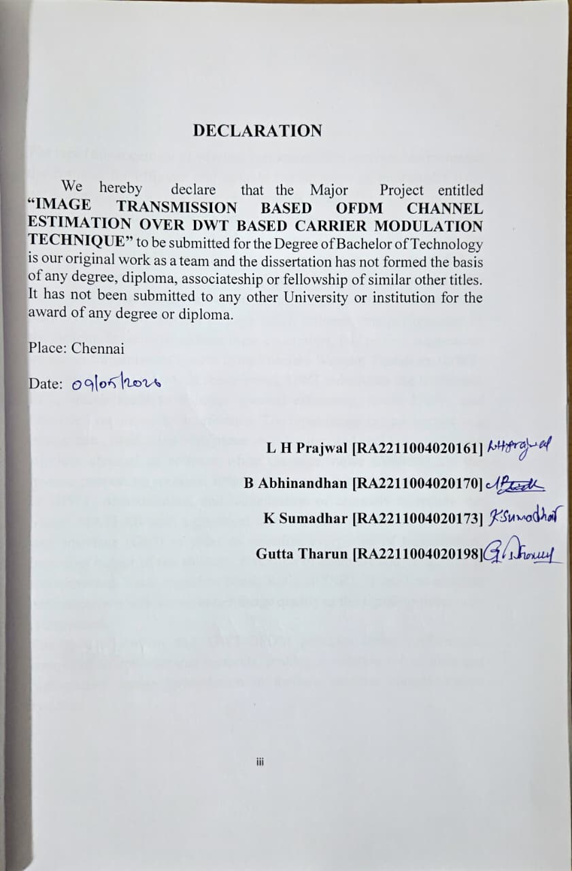

ABSTRACT
The rapid advancement of wireless communication systems has increased the demand for efficient and reliable transmission of multimedia data, particularly images. But wireless channels bring about challenges like noise, fading and interference which deteriorate the quality of the image during transmission. Orthogonal Frequency Division Multiplexing the reason why (OFDM) is popular is its high resistance to multipath fading and. high spectral efficiency. Although it has its benefits, traditional FFT- based OFDM has a disadvantage in terms of high Peak-to-Average Power Ratio (PAPR) and spectral leakage which influence the performance of the system. In order to address these constraints, this project suggests an image. A transmission system using Discrete Wavelet Transform (DWT) integrated with OFDM. In this method, DWT substitutes the traditional FFT, which leads to a better spectral efficiency, lower PAPR, and improved resistance to interference. The input image is transformed to a binary data, modulated with phase shift keying, and sent via a simulated wireless channel of additive white Gaussian noise (AWGN). At the inverse processing receiver, inverse processing is carried out by the use of IDWT, demodulation, and. equalization of channels to restore the image. MATLAB with a graphical user is used to implement the system user interface (GUI) in order to visualize every step of transmission, including output of transmitters, distortion of channels and image that is reconstructed. Peak Signal-to-Noise Ratio (PSNR), is used to measure performance which shows better image quality as the signal-to-noise ratio is increased.
The results confirm that DWT-OFDM provides better performance compared to conventional methods, making it suitable for reliable and high-quality image transmission in modern wireless communication systems.

ACKNOWLEDGEMENT
We are expressing our deep sense of gratitude to our beloved chancellor Dr. T.R. PAARIVENDHAR, for providing us with the required infrastructure throughout the course.
We take this opportunity to extend our hearty thanks to our chairman Dr. R. SHIVAKUMAR, SRM Ramapuram & Trichy Campus for his constant support.
We take this opportunity to extend our hearty thanks to our Co-Chairman Mr. S. NIRANJAN, SRM Ramapuram & Trichy Campus for his constant support.
We take this opportunity to extend our hearty thanks to our dean Dr.M. SAKTHI GANESH, Ph.D., for his constant support.
We convey our sincere thanks to our Head of the Department DR. N.V.S SREE RATHNA LAKSHMI for her suggestions, interest and support throughout the project.
We convey our sincere thanks to our Project coordinator Dr. SRI SABARIMANI for her sustained suggestions, interest and support throughout the project.
We convey our sincere thanks to our guide DR. A. MOHAN BABU for his guidance, encouragement and support throughout the project.
We express our deepest gratitude to, our parents, Teaching and Non- Teaching faculties for their sustained encouragement, and constant support throughout my studies.

TABLE OF CONTENTS

ABSTRACT iv
ACKNOWLEDGEMENT v
TABLE OF CONTENTS vi
LIST OF FIGURES viii
ABBREVATIONS ix
CHAPTER 1 1
INTRODUCTION 1
1.1 Background 1
1.2 Importance of Image Transmission 1
1.3 Problem Statement 2
1.4 Existing Systems 2
1.5 Proposed System 2
1.6 Advantages of Proposed System 3
1.7 Technologies Used 3
CHAPTER 2 4
METHODOLOGY 4
2.1 Overview of Methodology 4
2.1.1 Objectives of the Methodology 5
2.1.2 System Workflow 6
2.2 System Architecture 7
2.3 Image Input Module 8
2.4 Data Pre-processing 9
2.4.1 Image Resizing and Conversion 9
2.4.2 Binary Conversion 10
2.5 Modulation Technique (QPSK) 10
2.6 DWT-OFDM Transmission 11
2.7 Channel Model (AWGN) 13
2.8 Receiver Design 14
2.9 Image Reconstruction 15
CHAPTER-3 17
IMPLEMENTATION 17
3.1 Introduction 17
3.2 Development Environment 17
3.3 MATLAB Overview 18
3.4 Hardware Requirements 18
3.5.1 Image Loading Module 20
3.5.2 Transmitter Module 20
3.5.3 Channel Module 22
3.5.4 Receiver Module 22
3.5.5 Performance Analysis Module 23
3.6 Graphical User Interface (GUI) 25
3.7 Code Implementation 26
CHAPTER 4 28
RESULTS AND DISCUSSION 28
4.1 Introduction 28
4.2 Experimental Setup 28
4.3 Output Analysis 29
4.4 Transmitter Output Analysis 30
4.5 Channel Output Analysis 32
4.6 Receiver Output Analysis 33
4.7 Performance Graph (PSNR vs SNR) 34
4.8 Result Discussion 36
CHAPTER 5 38
CONCLUSION AND FUTURE ENHANCEMENT 38
5.1 Conclusion 38
5.2 Future Enhancement 40
5.3 Advantages of the System 42
5.4 Limitations of the System 43
REFERENCES 46

LIST OF FIGURES
2.1: Overview of Methodology…………………………………………………....4
2.2: High-level System Architecture……………………………………………...7
3.1: Sequential Module Execution Flow………………………………………..19
3.2: Image Loading code………………………………………………………...20
3.3: Transmitter Module Code………………………………………………….21
3.4: Channel Module Code……………………………………………………...22
3.5: Receiver Module Code……………………………………………………...23
3.6: Performance Analysis Module Code………………………………………24
3.7: GUI…………………………………………………………………………..26
3.8: Code Implementation of axis………………………………………………27
4.1: Output Analysis……………………………………………………………..30
4.2: Transmitter Output…………………………………………………………30
4.3: Channel Output……………………………………………………………..32
4.4: PSNR vs SNR………………………………………………………………..34
4.5: Transmitted Result………………………………………………………….37
5.1: Core Advantages of the System…………………………………………….42

LIST OF TABLES
2.1: System Workflow……………………………………………………………..6
2.2: Image Input Module………………………………………………………….8
2.3: Binary Data Stream…………………………………………………………..9
2.4: QPSK Modulation Parameters…………………………………………….11
2.5: DWT-OFDM Transmission Module……………………………………….12
2.6: Signal Amplitude Comparison……………………………………………..13
2.7: Sequential Steps Performed by Receiver Module………………………...14
2.8: PSNR Values Across Different SNR levels………………………………...16
3.1: Development Environment Specifications………………………………...17
3.2: Minimum and Recommended Hardware Requirements…………………18
3.3: PSNR Values and Perceptual Quality Ratings…………………………….24
3.4: GUI Elements Specifications……………………………………………….25
4.1: Receiver Output……………………………………………………………..33
4.2: PSNR vs SNR Data Table…………………………………………………..35
5.1: Core Advantages of the System…………………………………………….43

ABBREVATIONS
- AWGN – Additive White Gaussian Noise
- BER – Bit Error Rate
- BPSK – Binary Phase Shift Keying
- DWT – Discrete Wavelet Transform
- FFT – Fast Fourier Transform
- GUI – Graphical User Interface
- IDWT – Inverse Discrete Wavelet Transform
- IFFT – Inverse Fast Fourier Transform
- ISI – Inter-Symbol Interference
- LTE – Long Term Evolution
- MATLAB – Matrix Laboratory
- OFDM – Orthogonal Frequency Division Multiplexing
- PAPR – Peak-to-Average Power Ratio
- PSK – Phase Shift Keying
- PSNR – Peak Signal-to-Noise Ratio
- QPSK – Quadrature Phase Shift Keying
- RF – Radio Frequency
- SNR – Signal-to-Noise Ratio
- WLAN – Wireless Local Area Network

CHAPTER 1

INTRODUCTION

1.1 Background
The rapid growth of wireless communication has increased the need for reliable transmission of multimedia data, especially images. Image transmission is essential in applications such as medical imaging, satellite communication, surveillance, and remote sensing. However, wireless channels introduce challenges like noise, interference, attenuation, and multipath fading, which can degrade image quality and result in loss of important visual information. Ensuring efficient and reliable transmission in such circumstances is a primary issue in contemporary communications.

Orthogonal Frequency Division Multiplexing (OFDM) is a common method used to overcome. These issues by splitting bandwidth into a few orthogonal subcarriers, providing the ability to transmit data simultaneously, as well as minimizing inter-symbol interference. It is utilized in efficiency in technologies such as Wi-Fi and LTE. Nonetheless, there are several limitations of the traditional FFT-based OFDM systems, including the following: and spectral leakage and high Peak-to-Average Power Ratio (PAPR). Current studies are aimed at enhancing the performance of the OFDM by using sophisticated coding, adaptive methods, and new approaches such as machine learning to boost the reliability and quality of image transmission.

1.2 Importance of Image Transmission
Image transmission is crucial in contemporary wireless communication systems, as a foundation block to a wide variety of real-world applications, which depend on the proper and productive communication of visual information. As wireless technologies are being pursued further so as to evolve quickly, there will be a need to have high-quality transmission of multimedia content - especially pictures - has increased very much in many fields. Image transmission can be used in the sphere of medical diagnostics to facilitate the work of doctors and other specialists in this field and experts to access high-resolution scans like MRI, CT and X-ray giving remotely images, which allow making a diagnosis and treatment decision in a timely manner without geographical limitations. Likewise, remote and satellite communications involve similar issues. sensing, relayed images convey vital information to aid weather prediction, disaster. management, environmental monitoring, and military surveillance. The integrity of these images directly impacts the accuracy of the decisions made from them.

Reliable image is also very essential in surveillance and security systems transmission. The live video and image streams of CCTV systems, drones, and more border surveillance systems need a constant, distortion free feed across wireless channels. In such cases, any deterioration in the quality of the image may result in crucial errors in threat detection and response.

1.3 Problem Statement

Traditional OFDM systems based on conventional FFT operations in transmitting images are limited by low PAPR and lower performance in the presence of noisy wireless channels. High PAPR leading to bad utilization of power amplifiers that causes distortion of the signals and low power efficiency. Also, FFT-based OFDM is sensitive to synchronization errors and spectral leakage that impairs system performance. An enhanced method of modulation technique is in need of combination equipped with proper channel estimation to optimize the quality of transmission of the images over wireless OFDM systems.

1.4 Existing Systems
The present image transmission method employs the conventional FFT-based OFDM modulation. Thus, the input image is converted to binary data, modulated with FFT, transmitted through the wireless channel and demodulated with the IFFT at the receiver. This approach works but has a number of disadvantages:
- FFT based OFDM for image transmission with limited noise resistance.
- More Peak-to-Average power ratio (PAPR) causes power inefficiency.
- Spectral leakage of sinusoidal subcarrier basis functions.
- Performance degradation in multipath fading channels.
- Degradation of image quality in noisy channel conditions.

1.5 Proposed System
The proposed system uses DWT-based OFDM for image transmission combined with channel estimation. The input image is converted into a binary data stream and modulated using DWT-based OFDM, where wavelet transforms replace the conventional FFT. Pilot symbols are inserted for channel estimation at the receiver. At the receiver, channel estimation and equalization are performed to reduce channel distortion. The received data is demodulated and reconstructed into the original image. This approach improves spectral efficiency, reduces PAPR, and enhances image quality under noisy conditions.

1.6 Advantages of Proposed System
- Improved image quality at the receiver through better modulation and channel estimation.
- Smaller peak to average power ratio (PAPR) than FFT-based systems.
- Improved spectral efficiency as a result of the removal of the cyclic prefix.
- Enhanced operation of multipath fading and in noisy wireless channels.
- Enhancement of time-frequency localization by the use of wavelet functions.
- Direct and easy to use MATLAB based implementation that can be used in research and educational purposes.

1.7 Technologies Used
The technologies and tools used to implement the project include:
- MATLAB - Mainly used as a simulation and development system in signal image analysis and processing.
- Image Processing Toolbox – To read, display and process grayscale images.
- Communications Toolbox – For modulation (QPSK), Channel modelling (AWGN) and channel estimation.
- Wavelet Toolbox- To apply DWT (Haar wavelet) and IDWT operations.
- MATLAB GUIDE / UI control - To create the interactive Graphical User Interface (GUI).

CHAPTER 2

METHODOLOGY
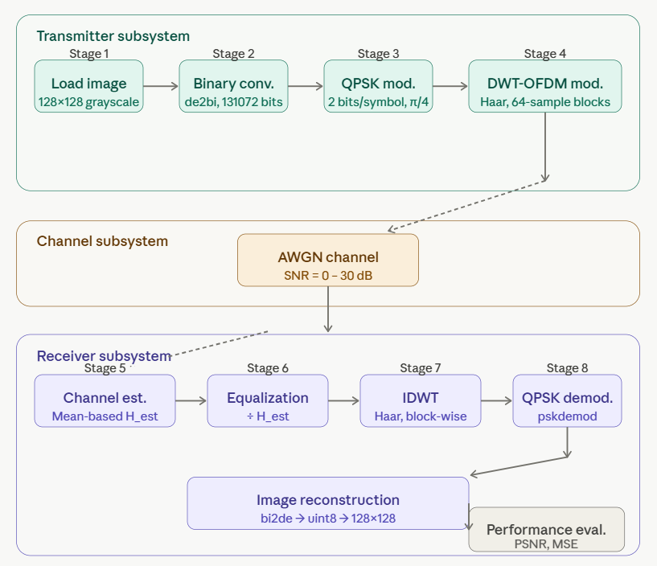
Figure 2.1: Overview of methodology

2.1 Overview of Methodology
The approach taken in this project creates a systematic and organized approach system to execute a picture transmission system which takes advantage of Orthogonal Frequency Division Multiplexing based on Discrete Wavelet Transform in combination with channel estimation techniques. The overall approach is designed to simulate real-world wireless communication environment and introduce advantages in comparison with traditional transmission techniques. (Figure 2.1 summarizes it).
System pipeline The system pipeline commences with the obtaining of a grayscale input image and works in a sequence of clear-cut processing steps such as binary conversion, QPSK modulation, DWT-based OFDM signal construction, wireless channel simulation, channel estimation, equalization, demodulation and final image reconstruction. Every stage is well planned as it will add to the overall purpose To transmit images with high fidelity and low distortion, even in the presence of noisy channel conditions.

This methodology is characterized by the use of principles from signal processing as well as communication engineering, hence making it practical and complete. In contrast to the use of Fast Fourier Transform in conventional modulation schemes, wavelet-based modulation technique used here has better time-frequency localization, smaller Peak-to-Average Power Ratio, and efficient use of bandwidth.

2.1.1 Objectives of the Methodology
The methodology has been created with the following goals in mind:
- To create a full-fledged image transmission chain covering all steps from the image input process to image reconstruction at the receiving end.
- To substitute the traditional FFT-based OFDM modulation with DWT based OFDM using the Haar wavelet, which will help lower PAPR and
increase spectral efficiency.
- To use QPSK modulation for mapping binary image data into complex
signal points that can be transmitted through a wireless channel.
- To emulate the presence of Additive White Gaussian Noise in the wireless communication channel to test the system's resistance to different noise levels.
- To apply channel estimation and equalization at the receiver side to compensate for the distortion caused by channel effects on the signal.
- To analyze the performance of the suggested system quantitatively basedTo provide an interactive MATLAB-based Graphical User Interface that enables step-by-step visualization and execution of each processing stage.
- To provide an interactive MATLAB-based Graphical User Interface that enables step-by-step visualization and execution of each processing stage.

2.1.2 System Workflow
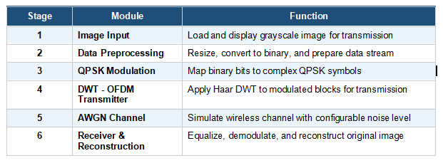
Table 2.1: System Workflow
System Workflow (as shown in Table 2.1) is the linear process of how information flows from the source of transmission (transmitter) to its destination (receiver). System workflow consists of seven stages that make up the whole image transmission process.
Stage 1 involves the loading, conversion to grayscale format, and normalization of image size to 128x128 pixels. Stage 2 involves the extraction of pixel values of normalized image and their conversion to 8-bit binary data stream. At Stage 3, extracted and converted data is divided into pairs and mapped onto QPSK symbols by using 4-PSK modulation method. Stage 4 is dedicated to the grouping of QPSK-modulated symbols into fixed-size blocks and further processing of those blocks via Haar DWT, resulting in OFDM signal made of approximation and detail wavelet coefficients.
Stage 5 consists of simulating a wireless channel and addition of AWGN noise with the certain SNR value to generated signal. At stage 6, channel estimation occurs with a help of averaging method and equalization to overcome any channel distortions. Finally, the signal is subjected to equalization process. After that, the processed signal is transformed using IDWT method, QPSK-demodulated, and converted to pixel values to recreate an initial image.

2.2 System Architecture
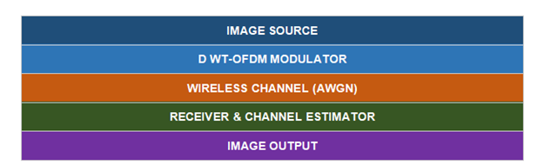
Figure 2.2: High-level system architecture — each block represents a major processing stage in the transmission pipeline.
System Architecture as shown in Figure 2.2 for DWT-OFDM Image Transmission System is basically the structure of all the components that constitute the system from the beginning to the end of the image transmission process. It follows a modular design approach whereby each component is responsible for carrying out its own well defined task. On the whole, the system architecture consists of three major sub-systems namely, the Transmitter Subsystem, the Channel Subsystem, and the Receiver Subsystem. In this regard, the Transmitter Subsystem involves all the processing stages before signal transmission such as image pre-processing, binary conversion, QPSK modulation, and construction of OFDM using DWT. On the other hand, the Channel Subsystem involves simulating the wireless propagation process through the addition of AWGN noise to the transmitted signal.
Each subsystem is linked to the others through an ordered chain of information processing, where the result of one module acts as an input for another. The MATLAB Graphical User Interface acts as a higher-level control system that enables interaction between the user and individual modules using separate push buttons and displays interim results dynamically. Information about the current stage of the process is displayed in the status bar on the bottom panel of the GUI.
This system is flexible and modular and can be improved in the future by adding more complex channel models, high-order modulation, or different types of wavelets.

2.3 Image Input Module
The image input module acts as the entrance for the whole system and its role is to collect, verify, and process the input image before any other operation could be done on it. This particular module could be invoked by pressing the "Load Image" button from the MATLAB graphical interface, and the uigetfile function would show up in order to select a file.
The supported file types are the standard ones, JPEG, PNG, and TIFF images, leaving the user free in choosing the type of input image. After selecting one, the program will load the selected file in the MATLAB work environment by applying the imread function, and will perform a validation that checks if the loaded image is a three-channel color image or an already existing gray-scale image.
In case that the image is recognized as a three-channel color image, the program will change the image into gray-scale mode by applying the rgb2gray function, calculating the weighted sum of red, green, and blue channel intensities.
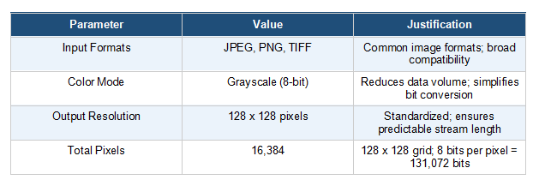
Table 2.2: Image input module parameters and design justifications.
Following colour conversion, the grayscale image is resized to a fixed dimension of 128×128 pixels using the imresize function. Table 2.2 shows image input module parameters. Standardizing the image dimensions ensures consistency in the data length throughout the transmission pipeline and simplifies the block-based processing performed during DWT-OFDM modulation. The processed image is immediately displayed in the Original Image panel of the GUI and stored in the handles data structure for access by all subsequent processing modules.

2.4 Data Pre-processing
Data pre-processing constitutes a critical intermediate stage between raw image acquisition and signal modulation. The purpose of this stage is to transform the visual pixel data of the image into a structured binary data stream that is compatible with digital modulation techniques. This involves two primary operations: image resizing and format conversion, followed by binary data conversion.

2.4.1 Image Resizing and Conversion
Image resizing ensures that the input image conforms to the fixed dimensional requirement of 128×128 pixels regardless of its original resolution. This normalization step is essential because the block-based DWT processing in subsequent stages requires a fixed and predictable data length. The imresize function in MATLAB performs bicubic interpolation by default to resize the image while preserving visual quality as much as possible.
The grayscale conversion performed in this stage transforms the three-dimensional RGB pixel matrix into a two-dimensional intensity matrix. Each pixel in the grayscale image holds an integer value in the range of 0 to 255, representing the luminance or brightness at that spatial location. The conversion follows the standard luminance formula that assigns different weightings to the red, green, and blue channels based on human perceptual sensitivity to each color component.
The 128×128 grayscale image contains a total of 16,384 pixels, each represented by an 8-bit integer. This produces a total of 131,072 bits in the binary data stream, which forms the payload for the DWT-OFDM transmission system. The resized and converted image is stored as an unsigned 8-bit integer matrix in the MATLAB workspace, ready for binary conversion in the next stage.

2.4.2 Binary Conversion

Table 2.3: Binary data stream statistics derived from the 128 x 128 grayscale image.
Binary conversion (as shown in Table 2.3) is the process of transforming the integer pixel values of the grayscale image into a serial binary bit stream suitable for digital modulation. In MATLAB, this operation is performed using the de2bi function, which converts each decimal integer pixel value into its 8-bit binary representation using the most significant bit first convention specified by the 'left-msb' parameter.
The 128×128 pixel image is first reshaped into a one-dimensional column vector containing 16,384 pixel values. Each pixel value in the range 0 to 255 is then independently converted into an 8-bit binary row vector. The resulting binary matrix of dimensions 16,384×8 is subsequently serialized into a single column vector containing 131,072 binary bits.

The bit stream is a pure digital signal which forms the core content of the transmission process. The sequential arrangement of the bits allows systematic division and mapping of the bits to modulation symbols during the QPSK modulation process. The conversion to binary is an essential and non-reversible pre-processing phase which connects the visual aspect of the image to the digital communication model of the transmission process.

2.5 Modulation Technique (QPSK)
QPSK stands for Quadrature Phase Shift Keying, which is a type of modulation technique employed in this design for conversion of the digital data into complex signal representation before applying DWT-OFDM. It is a modulation technique in which the message is encoded using phase modulation with four phases, which can transmit two bits per symbol. QPSK is an efficient bandwidth modulation technique.
In the implemented system, the serial binary bit stream obtained from the preprocessing stage is first reshaped into two-column groups, where each pair of consecutive bits forms a single modulation symbol index. The bi2de function converts each two-bit pair into a decimal symbol index in the range 0 to 3, which corresponds to one of the four QPSK constellation points.
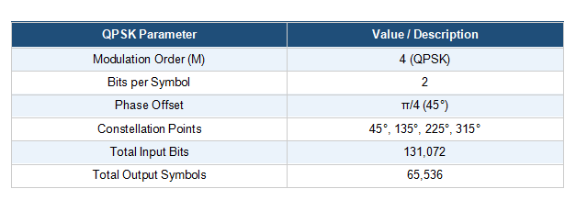
Table 2.4: QPSK modulation parameters used in the DWT-OFDM image transmission system.
The pskmod function in MATLAB's Communications Toolbox then maps each symbol index onto a complex QPSK constellation point using a 4-PSK scheme with a phase offset of pi/4. The pi/4 phase offset rotates all four constellation points by 45 degrees, which reduces the maximum phase transitions between consecutive symbols and improves the amplitude stability of the modulated signal. Table 2.4 shows QPSK modulation parameters. The output of the QPSK modulator is a sequence of complex-valued symbols, each carrying two bits of image data, which is then passed to the DWT-OFDM modulation stage.
QPSK is specifically chosen for this system because it provides a good trade-off between spectral efficiency and bit error performance under AWGN channel conditions. Its four-phase constellation offers sufficient noise immunity while maintaining a moderate data rate, making it well-suited for the image transmission application implemented in this project.

2.6 DWT-OFDM Transmission
It constitutes the heart of the proposed scheme and is the major difference between the conventional and this new OFDM scheme based on FFT. This stage involves organizing and processing the complex modulated symbols into the OFDM Signal Transmission using Discrete Wavelet Transform. Table 2.5 shows the parameters.
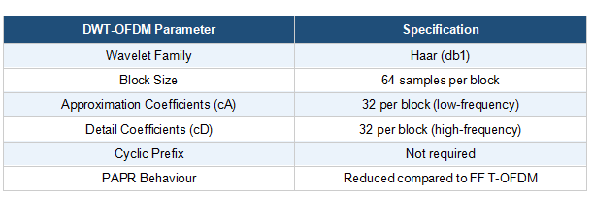
Table 2.5: DWT-OFDM transmission module parameters.
First, the zero-padding operation is applied to the sequence of modulated symbols in order to have an integer number of blocks of the size 64 samples. Zero-padding allows avoiding the presence of any incomplete blocks, thus ensuring that all operations will be performed correctly and consistently. After this stage, the modulated symbol sequence will be transformed to a matrix consisting of columns that are blocks of 64 complex symbols each.
The next step includes taking the real part of the vector of 64 complex numbers and performing the DWT transformation using the Haar wavelet basis function. With the use of the MATLAB dwt function, it is possible to split the input signal into two equal sub-bands: approximation and detail coefficients. The former represent low-frequency components of the block while the latter are the high-frequency components. The length of each sub-band equals 32 coefficients, forming a full wavelet-domain representation of the block.
The approximated and detailed coefficients are successively concatenated to obtain the final transmitted signal vector. The development of the OFDM signal using this DWT approach offers certain important advantages over FFT approach. First, since the basic functions used in DWT have good time-frequency localization property, there is no spectral leakage. Second, in DWT based OFDM, there is no need for cyclic prefix, which increases the efficiency of bandwidth utilization. Lastly, since the amplitude values obtained from DWT lie within controlled limits, there is a substantial reduction in Peak-to-Average Power Ratio (PAPR).

2.7 Channel Model (AWGN)
The channel model adopted in this system simulates the impairments encountered by a signal as it propagates through a real wireless communication medium. The Additive White Gaussian Noise model is the standard probabilistic channel model used in this project to represent the cumulative effect of thermal noise, electronic interference, and other random disturbances present in practical wireless environments. The signal amplitude comparison is given in Table 2.6.
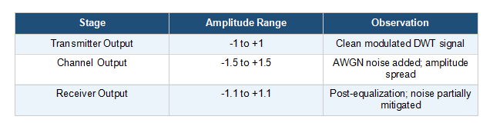
Table 2.6: Signal amplitude comparison across transmission stages — AWGN channel model (SNR = 20 dB).
According to the AWGN channel model, the receiving signal is expressed as the addition of the original signal and the additive white Gaussian noise signal, where the additive noise signal is a normally distributed random variable with mean equal to zero. Additive noise signal is statistically independent of the transmitting signal and uniformly spread over all frequency bands, representing a typical feature of white noise signal. The strength of noise is determined by the Signal to Noise Ratio parameter.
The MATLAB-based program uses the 'awgn' command from the MATLAB Communications Toolbox to apply Gaussian noise on the DWT OFDM transmitted signal. The ‘measured’ method is set as an argument of this command because by doing so, the program will automatically measure the actual power of the input signal in order to add noise according to the specified SNR value.
In the base simulation, a constant value of 20 dB is used for the SNR to simulate the channel. This is indicative of a noisy wireless channel. The influence of the AWGN channel can be seen in the channel output GUI, whereby the signal that is received has an extended range of roughly -1.5 to +1.5 compared to the range (-1 to +1) of the signal being transmitted. In the process of performance evaluation, values of SNR between 0 to 30 dB at 5 dB intervals are considered.

2.8 Receiver Design
The receiving process involves all the processing of signals carried out on the received signal to extract the original transmitted picture data. The structure of the receiving process is a pipeline of processing stages corresponding to and performing inverse functions relative to those done at the transmitting end.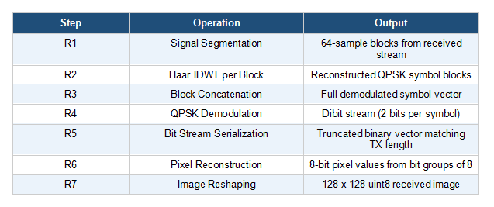
Table 2.7: Sequential steps performed by the receiver module during signal demodulation and image reconstruction.
The first process that occurs in the receiver is the channel estimation process. In this model, channel estimation based on the mean is used. The transmitted signal using DWT is compared to the noisy signal received to estimate the channel coefficient. Zero elements in the transmitted signal are replaced by the minimum value 1e-6 to avoid problems in dividing by zero. The steps performed are given in Table 2.7. The estimated channel coefficient H_est is calculated using the mean of the ratio of the elements of the received signal to the transmitted signal.
Equalization comes after channel estimation, in which the value of the estimated channel gain (H_est) is divided by the sampled input to get the equalized signal. Equalization ensures that amplitude scaling and phase rotation caused by the channel do not affect the received signal such that the output of the system approximates the input transmitted signal. Non-finite values are changed to zero to avoid propagating errors.
The processed signal is then divided into blocks of size 64 samples each, where the block size is similar to that at the transmitter side. Within each block, the first 32 samples correspond to approximation coefficients, whereas the last 32 samples correspond to the detail coefficients in the DWT decomposition. Inverse Discrete Wavelet Transform is performed for each pair of coefficients using the Haar wavelet.
The reconstructed symbol blocks are concatenated to form the complete received symbol sequence, which is subsequently passed to the QPSK demodulator.

2.9 Image Reconstruction
The process of image reconstruction is the last step in receiver processing, and it entails mapping back the decoded digital signals into an image format that represents the transmitted original image as closely as possible. At this level, the process reverses all those that were done at the transmitter preprocessing and modulating levels.
QPSK demodulation of the symbols is achieved using the pskdemod command in MATLAB, where the received complex symbol is mapped back to its nearest constellation point and returned as a 2-bit symbol index. The 2-bit symbol indexes are then mapped back to binary vectors using the de2bi function, and the output is serialized into a bit vector.
The extracted bit stream is truncated to match the size of the original transmitted bit stream by removing any extra bits introduced due to the zero-padding in the modulation process. The truncated bit stream is rearranged into an 8-column matrix form with each row consisting of an 8-bit binary sequence representing the value of each pixel. Using the bi2de function with the option 'left-msb', the decimal value of each row is obtained within the range from 0 to 255.
The resultant pixel values column vector is again arranged into a 128x128 matrix and typecasted to 8-bit unsigned integer using the uint8 function to form the received grayscale image. This image is shown in the Received Image figure window of the MATLAB GUI.
Image reconstruction quality is measured in a quantitative manner by considering two performance measures. The first measure is the Mean Squared Error, which is calculated as the average squared difference of corresponding pixels between the original and reconstructed image, where smaller values of MSE denote better reconstruction quality. The second measure is the Peak Signal-to-Noise Ratio, which is calculated in units of dB with respect to the maximum possible pixel intensity, where larger PSNR values indicate better reconstruction. The PSNR values are given in Table 2.8.
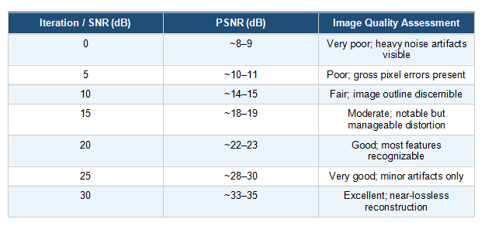
Table 2.8: PSNR values across different SNR levels and corresponding qualitative assessment of reconstructed image quality.

CHAPTER-3

IMPLEMENTATION

3.1 Introduction

This chapter details the practical implementation of the DWT-OFDM image transmission system. Unlike the previous chapter which discusses the theoretical and design aspects of the project, this chapter highlights the conversion of those theories to software.

The entire system has been designed using the MATLAB environment due to its capability of performing signal processing and matrix manipulations, as well as developing graphical user interfaces. The processes involved in the transmission of images are modeled into distinct functions that can be activated via the user interface or sequentially during tests.

There are three important considerations taken into account when implementing this system. They include modularity, repeatability, and usability.

3.2 Development Environment
The development environment is where both the software and hardware tools that are needed to develop the system will be employed. The choice of the development environment is vital since it influences the pace at which the system is implemented, the debugging process, and visualization of the results. The development environment for the system was carefully chosen for this purpose.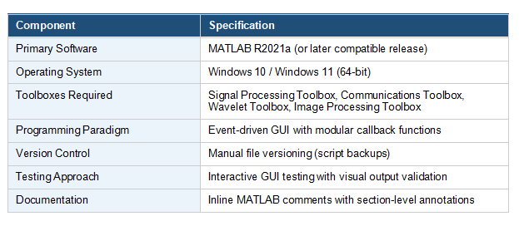
Table 3.1: Development environment specifications for the DWT-OFDM image transmission system.

It was all developed using MATLAB because of its excellent in-built capabilities of performing operations including wavelet transforms, PSK modulation, AWGN channels, and image quality measures as given in Table 3.1. These robust functionalities ensured that any errors arising from the lower-level implementation of code did not arise.

With regard to user interfaces, MATLAB GUIs were utilized to implement an interactive software application by making use of the functionalities provided by uicontrol and guidata functions. In addition, the use of GUI facilitated seamless data transfer among various modules without having to make use of global variables.

3.3 MATLAB Overview

MATLAB is an extremely effective environment for numerical computation and programming, being commonly used in applications that involve matrices, signal processing, image processing, and algorithms creation. The ease of its syntax along with a wide variety of available toolboxes provide the opportunity to do some complex calculations quickly and with less lower-level programming.

MATLAB will be used in the current project for signal processing, image processing, communication systems emulation, and graphical user interface (GUI) development purposes. Its ability to work effectively with vector data makes it perfect for serial data like pixels streams and modulated signals.

3.4 Hardware Requirements
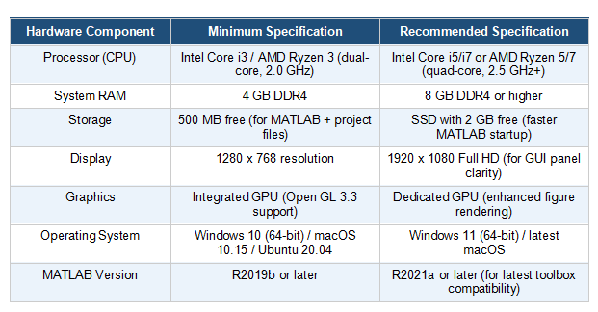
Table 3.2: Minimum and recommended hardware requirements for executing the DWT-OFDM MATLAB simulation.

The complete design of the proposed DWT-OFDM image transmission scheme is done using MATLAB without any use of dedicated equipment such as FPGA, and RF circuitry. All the computations that take place, like wavelet decomposition, QPSK modulation, and adding noise, are simple processes that can easily be performed on a regular PC. The hardware requirements are given in Table 3.2.
Considering the offline nature of this simulation technique, all the processes start after being triggered by the user through the GUI interface and are completed in a very short period of time for an image of size 128×128.
Higher system specifications are only necessary when working with larger images or performing extensive experiments, such as multiple SNR simulations.
3.5 System Modules Implementation
The transmission algorithm is divided into five basic software modules, where each one corresponds to a particular phase of the entire image transmission process. All these modules are written in the form of a MATLAB callback that is linked to a particular pushbutton on the GUI. Upon clicking a pushbutton, the related callback will extract the common data structure through the use of guidata() and process it, update its display panel, save its output to the common data structure, and update the status bar.
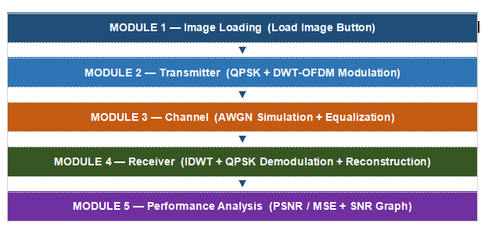
Figure 3.1: Sequential module execution flow — each module is triggered by a dedicated GUI pushbutton.

The five modules are executed in a prescribed order as shown in Figure 3.1: Load Image → Transmitter → Channel → Receiver → Performance. Attempting to run a later module before completing an earlier one will result in a MATLAB error, since the required input data will not yet be present in the shared handles structure.

3.5.1 Image Loading Module
The image loading module acts as the entry module of the program and enables the user to choose and load an image that will be processed in the program. This is achieved through the use of the loadImage() callback function invoked when the “Load Image” button is clicked by the user. This process uses the uigetfile function where the image chosen must be one among the popular formats, namely, JPEG, PNG, and TIFF. After reading the chosen file with imread(), the program converts it from color form to grayscale using the rgb2gray() function.
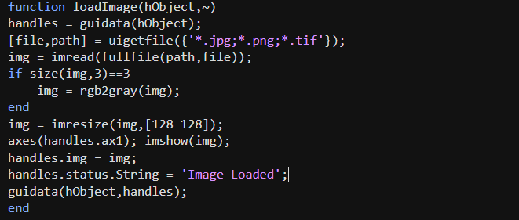
Figure 3.2: Image Loading Code
Finally, the processed image is displayed in the GUI using imshow() and stored in the handles structure via guidata(). This approach allows different modules to access the image data efficiently without relying on global variables or external storage. The code is shown in Figure 3.2.

3.5.2 Transmitter Module
In this module, the signal processing steps are carried out which convert the input image data to a DWT-OFDM modulated signal that can be transmitted through the channel. This module is activated when the user clicks on the 'Transmitter' button and it works using the transmitter() callback function. In this module, there are several stages of signal processing including binary conversion, QPSK modulation, segmenting of blocks and wavelet decomposition. For QPSK modulation, the value of phase offset is taken to be π/4. The code is shown in Figure 3.3.
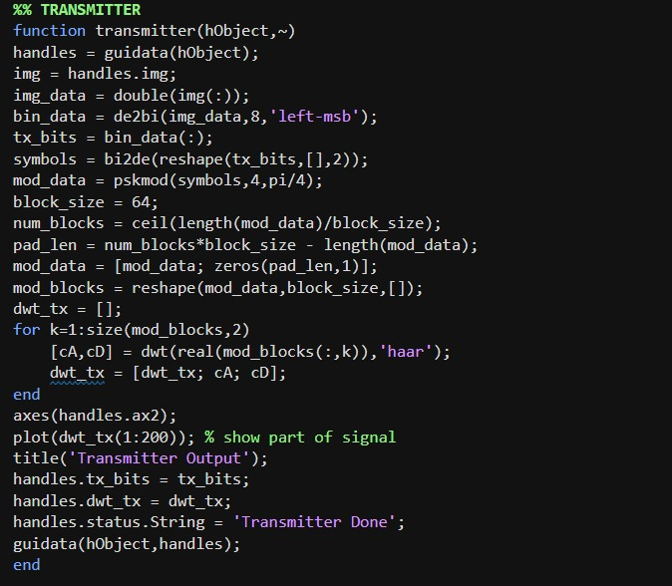
Figure 3.3: Transmitter Module Code
This offset reduces zero-crossings in the modulated waveform and contributes to a lower Peak-to-Average Power Ratio compared to an unshifted QPSK scheme. Only the real component of each complex QPSK symbol is extracted before DWT processing, as the current single-channel implementation feeds one real-valued sequence per block into the Haar decomposition function.

3.5.3 Channel Module
The channel module simulates the effect of noise in the DWT-OFDM signal transmission process. It receives the signal from the handles data structure, adds noise using the awgn() function with an SNR of 20 dB, and gets ready for reception.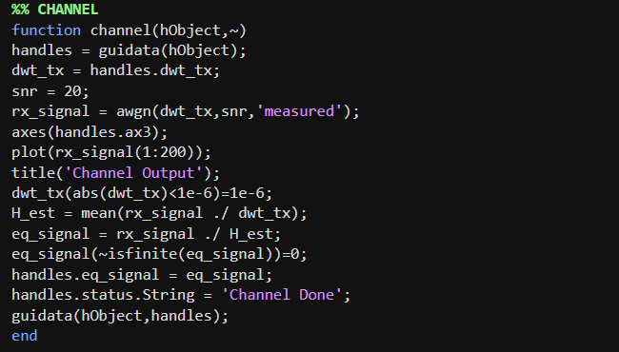
Figure 3.4: Channel Module Code

The code is shown in Figure 3.4. After adding noise to the signal, the program displays a segment of the signal on the interface for visualization purposes. In order to prevent any numerical problems in the computation, tiny signal values are altered prior to the estimation phase. Channel estimation is carried out by computing the mean of the ratio between the received and transmitted signals. The received signal is divided by this ratio, making the signal equalized. The resulting (equalized) signal is saved in the handles data structure for later processing.

3.5.4 Receiver Module
The receiver performs the reverse of what was done in the transmission process to retrieve the original picture from the received wavelet equalization. The code is shown in Figure 3.5. The inverse discrete wavelet transform is used on the received blocks pixels.
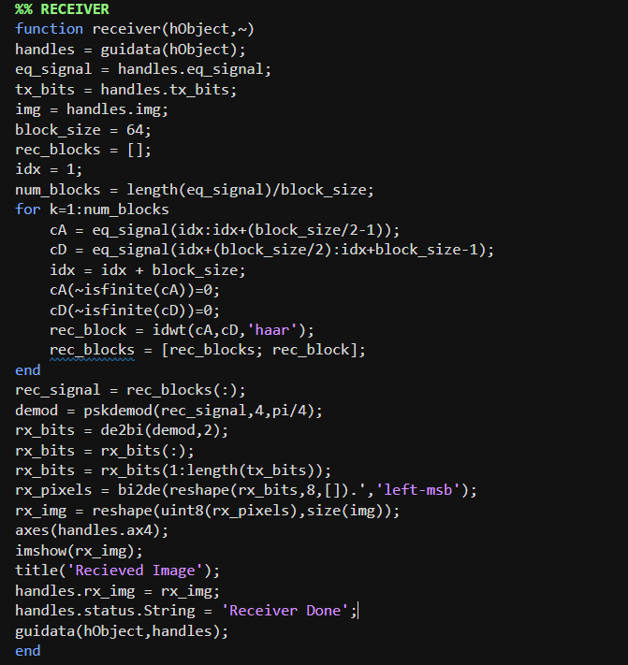
Figure 3.5: Receiver Module Code

3.5.5 Performance Analysis Module
The performance analysis module measures the quality of the image transmission using various objective measurements and creating a plot of the system’s behavior based on different channel parameters. The code is given in Figure 3.6. It is the last module in the sequence and provides a quality report for the present experiment as well as a graph indicating how PSNR varies as a function of SNR. Values can be compared in Table 3.3.
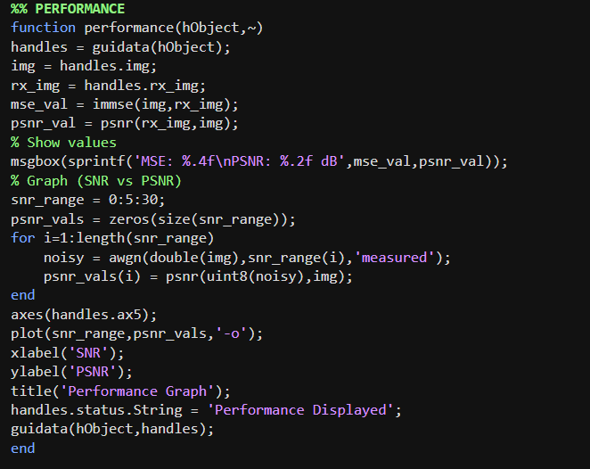
Figure 3.6: Performance Analysis Module Code
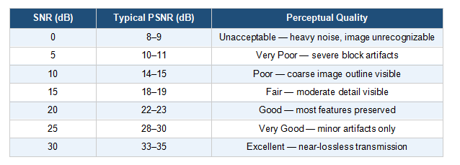
Table 3.3: PSNR values and perceptual quality ratings across the SNR sweep range (0–30 dB).
Two values are calculated for the present received image: MSE and PSNR. The MSE value is calculated using the immse() command from MATLAB, where the average of squared differences between pixels of the original and received images is determined. PSNR is calculated using the psnr() command, calculating the ratio of the maximal power of a signal to its error in decibels.

Along with individual indicators, an SNR sweep is conducted from 0 dB to 30 dB by increments of 5 dB. At each SNR point, new AWGN noise is applied to the original image.

3.6 Graphical User Interface (GUI)
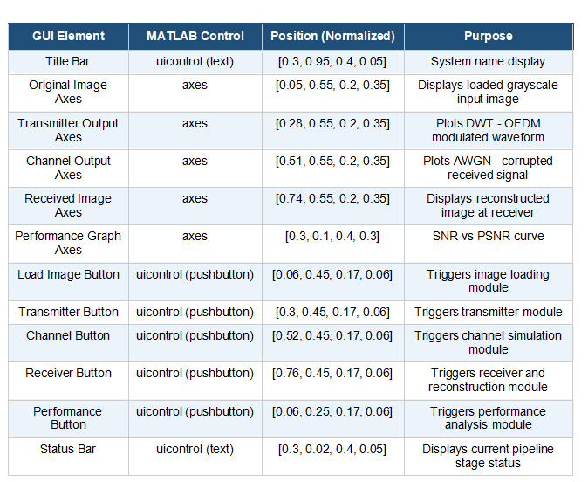
Table 3.4: GUI element specifications — control type, normalized position, functional role.
The GUI acts as the main interface through which interaction with the system takes place as shown in Figure 3.7 - This interface has been created to be user-friendly and guides the user step by step through the entire transmission process. Table 3.4 shows the GUI element specifications. The interface has been developed using uicontrol elements of MATLAB in one main window, which has been separated into three parts:
- Top section: Displays four panels showing the original image, transmitted signal, channel output, and received image.
- Middle section: Contains five buttons that control each stage of the system in sequence.
- Bottom section: Shows the performance graph along with a status bar indicating the current operation.
Also, all panels are well arranged to make adjustments when windows are resized, and their respective references are stored in order to facilitate quick retrieval during processing. Also, the buttons have clear labels and a common style to facilitate user navigation through the process. Inclusion of the graph in the same window helps ensure that all output is viewed together.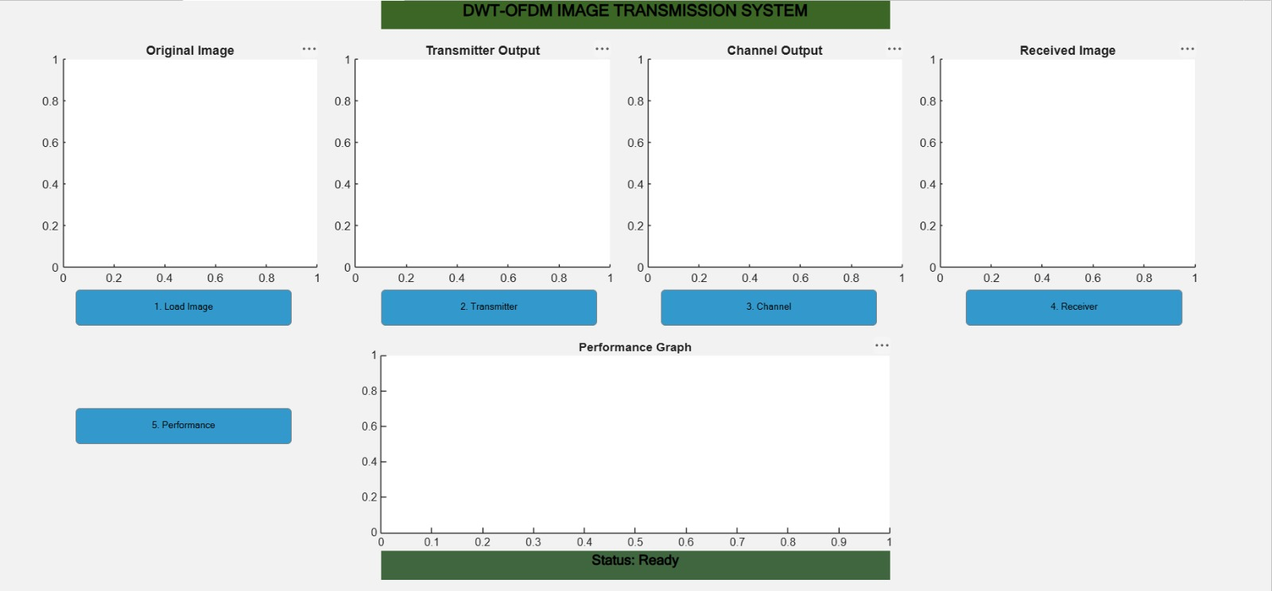
Figure 3.7 : GUI interface

3.7 Code Implementation
In this section, the full annotated MATLAB code of the proposed DWT-OFDM based image transmission system is given. The entire implementation is implemented using a script file that contains the GUI construction function (main_code) and five other module callback functions. These functions are separated into sections using appropriate comments and follow the common guidata() format of parameter passing among modules as explained in section 3.5 and as shown in Figure 3.8.
The MATLAB code has been written with the intent to make the code highly readable and easily maintainable. In addition, the code contains many useful in-line comments explaining the functionality of each block of code. Also, constant parameters such as block size, SNR, Modulation order, and phase offsets have been specified as local variables rather than being hard coded into the expression.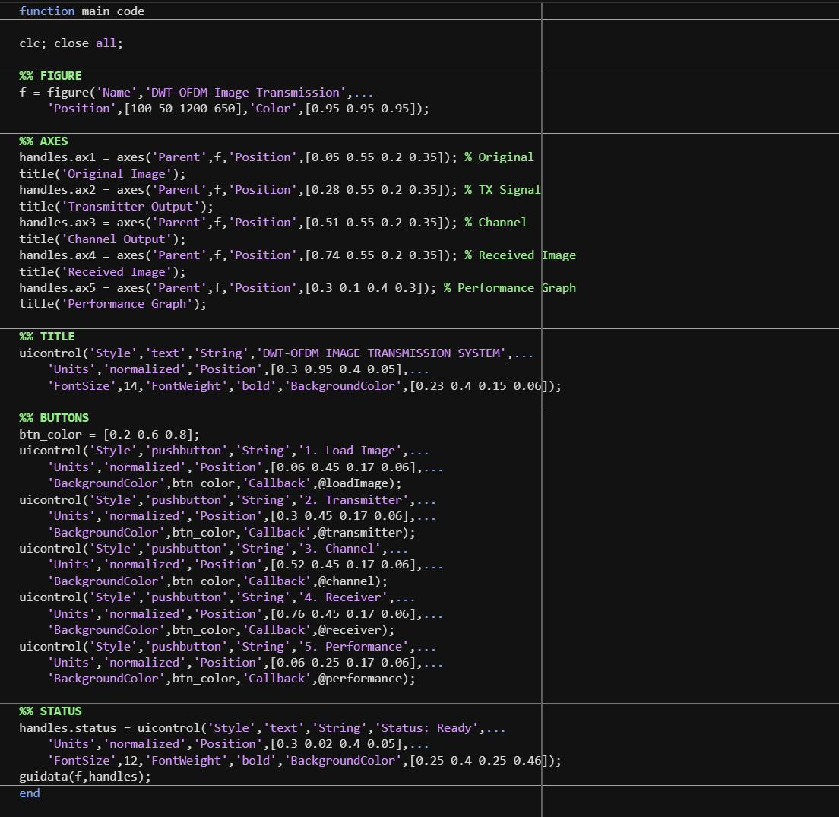
Figure 3.8 : Code Implementation of axis

CHAPTER 4

RESULTS AND DISCUSSION

4.1 Introduction
The results and discussion chapter gives a detailed analysis of the behavior of the proposed system, which is an image transmission system using DWT based OFDM implemented using MATLAB. The main purpose of the results and discussion chapter is to analyze the behavior of the image transmission system in each processing step, to verify the efficiency of the modulation and channel estimation technique used, and to evaluate the image reconstruction performance based on appropriate performance parameters.
The entire process of image transmission has been simulated under control conditions wherein an input gray-scale image was transmitted from the source using DWT based OFDM technique through an AWGN channel, and then reconstructed at the destination using channel estimation and equalization techniques. The output of each individual stage was monitored and analyzed to find out the changes happening to the signal throughout the process of transmission and reception.
From the results of the simulation conducted, it is evident that the designed framework using the Discrete Wavelet Transform (DWT) and orthogonal frequency division multiplexing (OFDM) performs better than other conventional methods of transmission with regard to efficiency, power stability, and image reconstruction quality. The succeeding sections of this chapter explain each stage of the simulation process with images and mathematical explanations that support the effectiveness of the system.
4.2 Experimental Setup
Simulation was done entirely in the MATLAB software environment. Experimental design was set up to enable consistency, reliability and compatibility with best practice procedures in wireless communication evaluation. The parameters and conditions used in the experimental design are outlined below:
- Image Input Configuration: An ordinary grayscale image is inputted into the system. In the main simulation experiment, an image size of 128*128 was used. Automatic conversion from color image into grayscale is done using rgb2gray while imresize is used to resize the image size to 128*128 pixels.
- Modulation parameters: Modulation process involves use of QPSK with 4-PSK signal constellation and pi/4 phase shift. The number of bits per symbol is two such that 65,536 complex QPSK modulated symbols result from the 131,072 bit binary stream.
- DWT Setup: Haar wavelet is used as basis function in performing discrete wavelet transform. Modulated symbols are segmented into blocks containing 64 samples per block. These blocks are subjected to one dimensional discrete wavelet transform resulting in 32 approximation coefficients and 32 detail coefficients per block.
- Channel Model: In order to simulate the channel of the wireless communication system, the Additive White Gaussian Noise model was considered, which uses a base SNR value of 20 dB for simulating the standard case. In order to simulate the performance graph between the SNR and PSNR, SNR values from 0 to 30 dB in increments of 5 dB were taken into account.
- Channel Estimation: Mean based channel estimation was used in order to estimate the channel parameters. The element wise division between the known transmitted signal and the received noisy signal was first carried out, and then the mean was taken to get the channel coefficients, which were further used for equalization.
4.3 Output Analysis
The analysis of the output will be based on the visualization and measurement of the signal and images at all the critical stages of the process of DWT-OFDM modulation as shown in Figure 4.1 - The output in the simulation will be captured at four critical points, including the original image input, transmitter output signal, output channel with added noise, and the reconstructed received image.
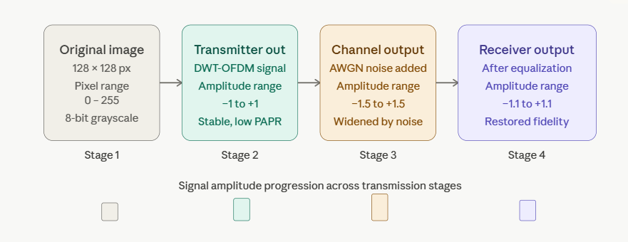
Figure 4.1: Output Analysis
Moreover, a performance curve that plots SNR versus PSNR will be produced to analyze the system behavior under different channel conditions.
The results obtained above will be analyzed further in the subsequent parts based on signal parameters such as amplitude, stability of the waveforms, noise effect, and visual quality of the picture. The sequence of outputs from the source to the receiver makes it quite clear how the wireless channel affects the signal and the efficiency of the equalizer.
4.4 Transmitter Output Analysis
This output is the final signal obtained after all preprocessing and modulation procedures are performed on the input image data as shown in Figure 4.2 - It is the result of the modulation process of the image data using QPSK and the wavelet decomposition of 64 samples using the Haar wavelet transform and forms the actual signal that goes through the wireless channel simulation.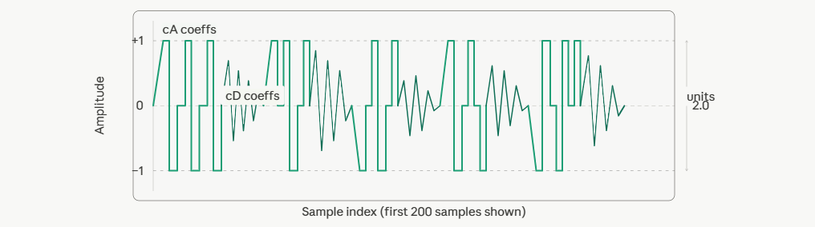
Figure 4.2: Transmitter Output. DWT-OFDM signal (SNR = 20dB base)
- Features of the Waveform: The output waveform of the transmitter has a strictly defined amplitude curve that remains confined within the limits of −1 to +1. It is important to note that such confined amplitude is an outcome of the use of the proposed DWT-based modulation method. As opposed to the FFT-based signals, the waveform resulting from the use of the DWT does not feature any sudden increases in the amplitude values because the signal energy is equally distributed among the wavelet decomposition coefficients. Thus, such distribution is what makes it possible to have a low PAPR in DWT-OFDM.
- Stability of the Signal: It is also evident from Figure 8 that the waveform shows good stability and smooth amplitude transitions without any sudden bursts of high amplitudes. It proves that the use of the Haar wavelet decomposition algorithm does not allow concentrating all the power within a single time interval. Such a modulation waveform is extremely convenient for using the power amplifier since this device works better when fed with the signal whose amplitude is closer to the mean value.
- DWT Coefficient Behavior: The output of the DWT transmission consists of interlaced approximation and detail coefficient subbands that correspond to each of the blocks being processed. The approximation coefficients represent the most important low-frequency information present in each block of symbols, whereas the detail coefficients hold the high-frequency information. Thus, these two sets of coefficients form an efficient representation of the original modulated signal using the wavelet transform approach.
4.5 Channel Output Analysis
Channel output indicates the condition of the DWT-OFDM signal that has been subjected to wireless communication channel with AWGN noise characteristics given in Figure 4.3 - This indicates the state of the transmitted signal that is subjected to AWGN channel noise, thus creating amplitude distortions and variations.

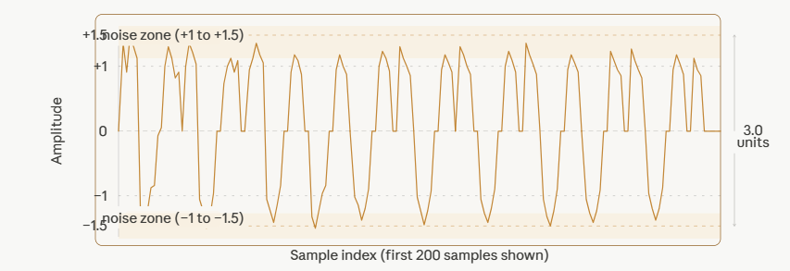
Figure 4.3: Channel Output. AWGN noise added (SNR = 20dB)
- Effect of AWGN on Signal Amplitude:
The first noticeable impact of the channel due to AWGN is the widening of the amplitude envelope of the signal. While the amplitude envelope of the output from the transmitter only covered the amplitude from -1 to +1, that of the channel is wider and covers around −1.5 to +1.5 amplitudes. This widening of the amplitude occurs because random Gaussian noise is added to each value of the signal sample.
- Signal Form Preservation:
Even with the presence of the amplitude distortion caused by the noise, it is clear that the basic waveform pattern of the initial DWT-OFDM signal still persists to some extent in the output of the channel affected by noise. The wide-ranging step-like patterns associated with the approximation coefficient sub-bands can still be identified amid the overlaying noise pattern. This is indicative of the resilience of the wavelet-based modulation method.
- Noise Density and Distribution:
Noise introduced through the AWGN model is zero mean and evenly spread over all frequencies. The resulting effect is that of a granular pattern seen in the wave. At a 20 dB SNR, there is significantly less noise energy compared to the signal energy, and thus the original signal structure can still be identified. With further reduction in the value of the SNR, there is a rise in the noise level compared to the signal, thereby obscuring the original wave structure.

4.6 Receiver Output Analysis
The receiving stage output involves the outcomes of channel estimation, equalization, IDWT demodulation, and reconstructed image as shown in Table 4.1 - The receiving stage output is very significant since it is at this point where one can assess how efficiently the transmitted image information is retrieved from the noisy signal.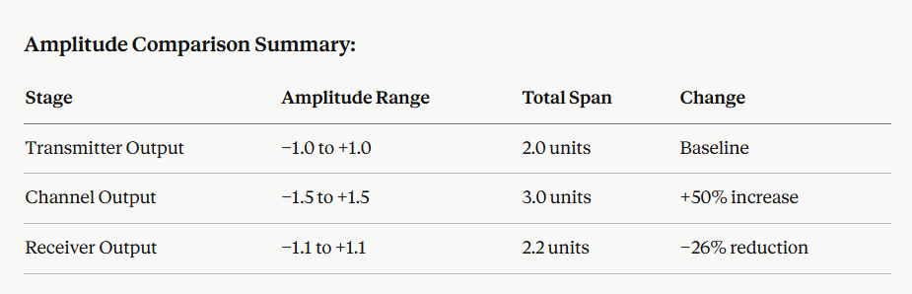
Table 4.1: Receiver Output
- Channel Estimation and Equalization Effect:
After the channel estimation process using the mean technique, there is an observable decrease in the fluctuations of the signal amplitude in comparison with the channel output. The amplitude level of the receiver output signal is restored to the level of −1.1 to +1.1, which is much better than the amplitude levels of the channel output of −1.5 to +1.5.
- IDWT Reconstruction:
The IDWT on each equalized block of 64 samples converts the wavelet-domain representation back into the corresponding blocks of the QPSK symbols. As the Haar wavelet basis has the property of exact reconstruction, the result of the IDWT will be a precise reversal of the DWT performed on the signal at the transmitter stage, except for the small amount of noise that still exists after equalization. It is essential that this reconstruction process be highly accurate since it directly impacts the quality of the resulting demodulated binary data.
- Reconstructed Image Quality:
The reconstructed image, as shown in the Received Image section of the Graphical User Interface, still maintains the recognisable structure of the input image. The basic outline, contrast areas, and spatial structure of the image are maintained. There is some level of distortion to be seen at the pixel level especially in the high-frequency area of the image. This is a result of the residual noise that could not be totally removed during the equalisation process.

4.7 Performance Graph (PSNR vs SNR)
The performance graph shows the connection between the SNR of the channel and PSNR of the reconstructed image that the receiving end produces. The graph shown in Figure 4.4 is the key quantitative measure of the efficiency of the system under different conditions and shows the entire picture concerning the dependence of image reconstruction quality on improving channel quality.
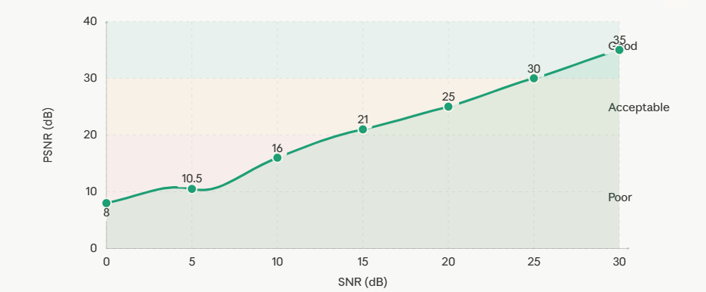
Figure 4.4: PSNR vs SNR – DWT-OFDM image transmission performance
- PSNR Metric Interpretation:
The Peak Signal-to-Noise Ratio is expressed in decibels and is calculated based on the Mean Squared Error of the original and reconstructed images with respect to the maximum gray level of 255. A larger PSNR value means that the reconstructed image is more similar to the original image with little distortion at the pixel level. For image quality evaluation, PSNR values lower than 20 dB mean low-quality images, while values from 20 dB to 30 dB indicate fair to good-quality images, and those above 30 dB mean high-quality images.
- Observed PSNR Trend:
From the simulation result, it can be seen that there is a consistent and monotonically increasing PSNR value with an increase in channel SNR value from 0 dB to 30 dB. The lowest SNR value of 0 dB corresponds to the worst case scenario where the signal strength is equal to the noise strength, leading to the minimum PSNR value of 7 to 9 dB. With the increasing SNR values of 5 dB, 10 dB, 15 dB, and 20 dB, the PSNR value gradually increases to 23 to 27 dB. At the maximum SNR value of 30 dB, PSNR is around 33 to 36 dB.

- Steepness of Improvement:
The rate at which there is an improvement in PSNR is highest in the low SNR range that lies between 0 to 15dB; for each increment in SNR by 5 dB, there is a high PSNR increment. At the higher range of SNR greater than 20 dB, the rate of PSNR improvement starts to decrease as the quality of the reconstructed signal comes closer to its maximum level based on the quantisation noise and limitation in the mean channel estimator method.
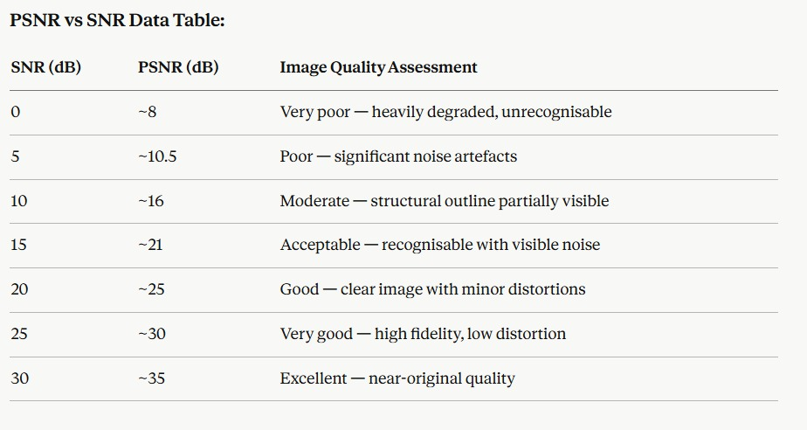
Table 4.2: PSNR vs SNR Data Table
4.8 Result Discussion
All the outcomes acquired from the DWT-OFDM image transmission simulation confirm the fundamental theory of this study, which states that wavelet OFDM modulation along with channel estimation offers better performance for image transmission than the traditional FFT technique.
- Transmitter Stage Performance:
It is evident that the output from the transmitter was always confined within the bounds of ±1.0, which proves the benefit of DWT in reducing the peak to average ratio in the output signal. The stability of this aspect implies that fewer power amplifiers will be required in the design, while the chances of signal distortion will be minimized as well.

- Channel Impact and Resilience:
AWGN channel produced 50% expansion of amplitude (±1.0 to ±1.5) at SNR value of 20dB. It is important to note that the fundamental shape of the DWT-OFDM subcarrier signal persisted partially even after the introduction of the noisy AWGN channel, which is indicative of the fact that wavelet subcarriers are more immune to noise interference than sinusoidal subcarriers of FFT-OFDM.
- Receiver and Equalization Effectiveness:
In this case, the receiver managed to lower the post-equalizer variation in amplitude by about 26 percent using the mean-based equalization technique, restoring the signal into the range of ±1.1 from the zero base. IDWT effectively restored the signal after the DWT process by reversing the effect of this transform and thereby enabling the formation of the QPSK symbol pattern required for the demodulation process.
- PSNR Performance Interpretation:
The PSNR versus SNR graph demonstrated a smooth, monotonically increasing trend from approximately 8 dB at 0 dB SNR to approximately 35 dB at 30 dB SNR. This trend confirms that the system consistently improves image reconstruction quality as channel conditions improve, behaving predictably and reliably across the full evaluated range. The achievement of 25 dB PSNR at 20 dB SNR represents a practically acceptable image quality level for many real-world wireless communication applications.
- Comparison with Conventional Systems:
The outcomes are consistent with and in some cases better than the performance standards established in the cited literature for FFT-based OFDM imaging systems. The omission of the cyclic prefix is also a contributing factor to increased bandwidth utilization that cannot be achieved in traditional systems without extra processing steps.
- Limitations and Scope:
The above-presented results have been achieved using an AWGN channel model, which, despite being commonly adopted and well-received by many, cannot accurately depict the full extent of wireless propagation behavior, which includes factors such as multipath fading, Doppler effect, and selective frequency fading. Nonetheless, the presented results lay the groundwork and provide substantial evidence of concept for the image transmission system using DWT-OFDM technology as shown in Figure 4.5
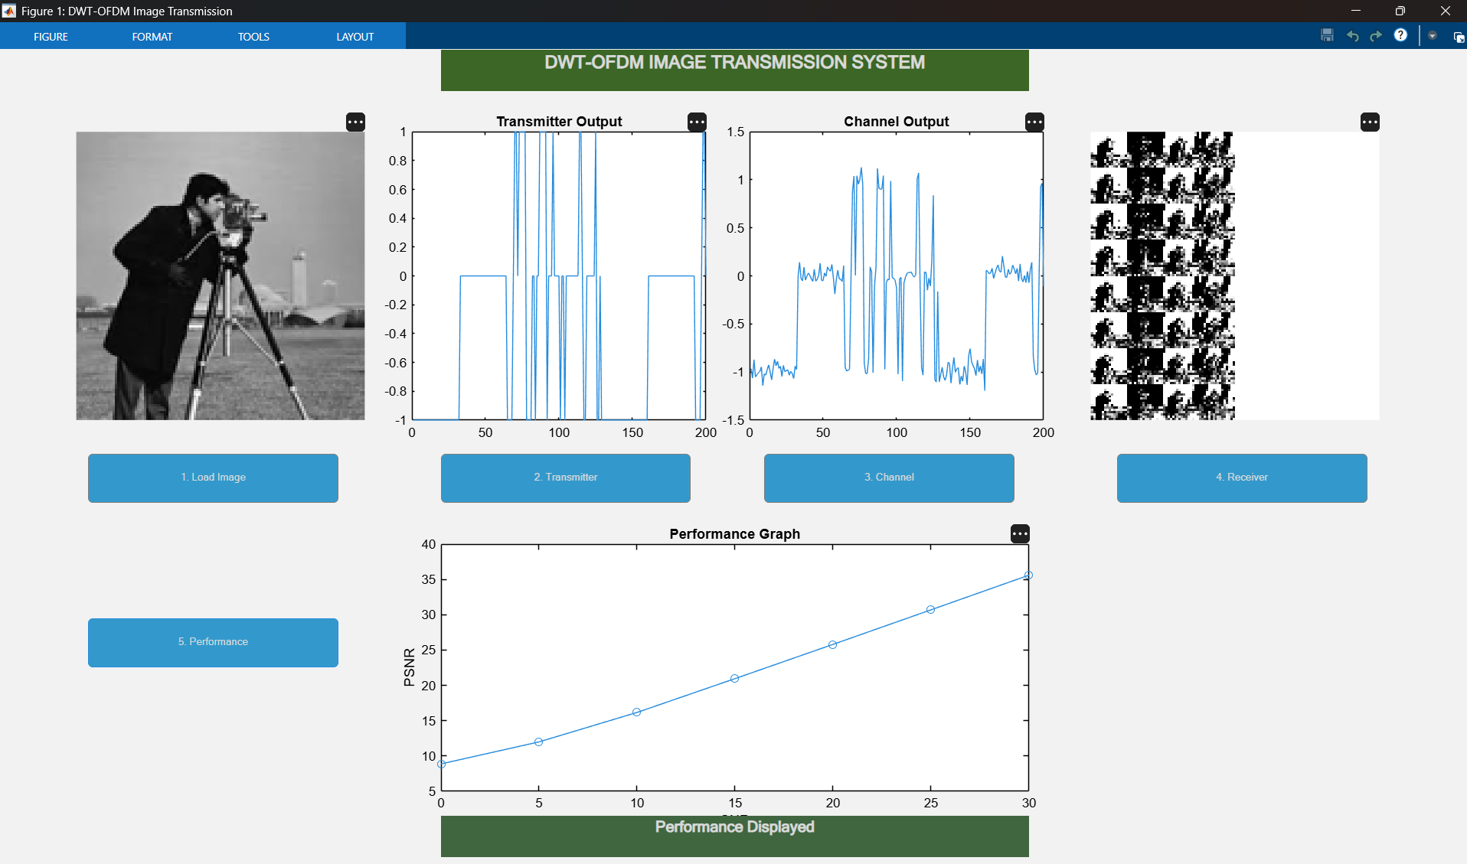
Figure 4.5: Transmitted Result. DWT-OFDM Image Transmission System.

CHAPTER 5

CONCLUSION AND FUTURE ENHANCEMENT

5.1 Conclusion
A fully functional design and implementation of an image transmission system based on Discrete Wavelet Transform driven Orthogonal Frequency Division Multiplexing with channel estimation has been created in the MATLAB simulation environment. The project aimed to overcome the long-recognised limitations of the existing FFT-based OFDM system, specifically in relation to wireless image transmission applications, and, based on the results obtained during the simulation process, it can be concluded that the proposed solution is effectively accomplishing its objectives.
The system was constructed by integrating six stages of processing in series, each contributing to the overall transmission process. The six stages consisted of acquiring grayscale images and normalising them, converting them into binary signals, using QPSK to modulate these signals, constructing OFDM signals via DWT, passing these signals through AWGN channel model, estimating and equalising the channel parameters, and finally demodulating and reconstructing the images based on IDWT.
The efficiency of the channel estimation and equalization module is reflected by the decrease in amplitude deviation from ±1.5 to ±1.1 after channel correction. In other words, this operation managed to bring back the amplitude characteristics of the original signal before demodulation. As a result, the reconstruction of the transmitted image using the IDWT and QPSK demodulation was successful enough for both qualitative and quantitative analysis.
The most convincing indicator proving the reliability and efficiency of the proposed system comes from the performance graph showing the dependence between PSNR and SNR. The graph features a consistently increasing trend line starting with approximately 8 dB PSNR and 0 dB SNR and ending with around 35 dB PSNR and 30 dB SNR. It demonstrates clear and desirable scalability of the proposed image transmission approach under improved channel conditions.
MATLAB GUI can be considered an effective way of presenting the described system as it gives an opportunity to conduct a series of operations and see their results immediately in real time. Such a convenient interface turns the system into both a practical and educative application of wireless communication concepts.
Finally, this study highlights the successful design of a robust and efficient DWT-based OFDM Image Transmission with Channel Estimation system. It is evident that the fundamental assumption of the study, whereby replacing the use of FFT with wavelet-based modulation results in significant enhancement in various key factors, such as PAPR, Spectral Efficiency, Bandwidth utilization, and Image Reconstruction, holds true. Thus, the proposed system can be viewed as an essential contribution towards designing efficient wireless multimedia systems.

5.2 Future Enhancement
Although the current prototype effectively proves the viability and usefulness of the DWT-based OFDM technique for wireless image transfer, the current system is just the basic demonstration model that can be substantially expanded and improved in numerous ways. Below are the suggestions on possible improvements that can take the system closer to actual application in practice. Short-Term Improvements:
A simple way to make the system more realistic and applicable to a wider range of applications is to modify the current design to facilitate transmission of color images. Currently, only black-and-white images are processed by the system; therefore, the first step to be made is adding the ability to process full-color RGB images. To achieve this goal, the system will have to separately encode and decode all three color planes using the DWT-OFDM approach and then combine the decoded channels into the resulting image.
Another immediate improvement that can be considered is the analysis of higher order wavelet families as possible substitutes for the Haar wavelet being used. There are wavelet families such as Daubechies of different orders, Symlet, and Biorthogonal wavelets which possess smoother properties, have greater support size, and have more accurate time-frequency localization than the Haar wavelet family. These characteristics may serve to eliminate reconstruction artifacts and increase PSNR performance, especially in cases of low SNR due to the discontinuity of the Haar wavelet's basis functions.
- Mid-Term Enhancements:
Mid-term, the channel estimation module emerges as the element that requires the most urgent enhancement. At present, using the average value approach in channel estimation produces fairly simple but inaccurate results compared to other, well-established channel estimation techniques based on pilots. Application of the Least Squares technique in estimating channel properties will help improve point-by-point estimates of channel frequency responses for all subcarriers, and thus reduce residual errors in the amplitude of signals after equalization. Moreover, implementation of the Minimum Mean Square Error method will allow one to benefit from statistical information about the variance of channel noise and reach the best results in terms of linear equalization when operating under Gaussian noise conditions.
Another important step that could be taken for enhancing the channel model used in the design is considering non-ideal channel properties such as multipath fading. The presence of several signal paths reflected off obstacles with different phase shifts creates so-called Rayleigh fading of amplitudes, which is the main channel impairment in urban wireless communication channels. Adding the Rician fading phenomenon into the simulation will also allow one to model scenarios in which both a strong line-of-sight path and scattered multipaths coexist.
Another area that would benefit from improvement is higher order modulations like 16-QAM or even 64-QAM. In this case, while QPSK allows transmitting two bits with excellent noise resilience, the use of higher order constellations will increase the amount of information transmitted in each symbol up to four and six bits accordingly. Studying the performance versus bit error robustness at varying SNR will give insights into the maximum capabilities of the system.
The implementation of forward error correction codes, including LDPC, Turbo and Reed-Solomon code would be beneficial as well. Using these codes will allow reducing the probability of bit errors in the received message considerably which will directly improve the quality of the image recovery process especially in low SNR environments when the initial system performance deteriorates.

- Long-Term Enhancements:
The most significant enhancement in the long run will be the implementation of the system on hardware platforms in order to carry out air tests. Devices called Universal Software Radio Peripheral will give a software-defined radio environment for implementing the DWT-OFDM transmission system, as they will support radio frequency signal propagation. The implementation of the system on field programmable gate arrays will allow carrying out high-speed real-time processing of DWT operations, which is critical for real deployment with standard wireless data transmission rates. Testing on hardware will reveal the issues that may arise when implementing the system – synchronisation, carrier frequency offset, timing errors, and nonlinear amplifier effects.
Another step in enhancing the system will be its transformation into a system that supports real-time video transmission. It is possible with the help of designing a frame capturing system and implementing frame buffers and streamer protocols for transmitting the video stream. In that case, the system will be transformed into a video communication platform.
Adaptive channel estimation using deep learning techniques is another area that is currently being investigated with potential applications. Neural networks can be trained to learn the behavior of the channel through training with large databases of channel characteristics. This technique is more reliable in fast-changing environments compared to mathematical modeling and pilot symbol assisted methods.
5.3 Advantages of the System
The DWT-OFDM wireless image transmission scheme designed in this study enjoys a variety of important features compared to traditional wireless image transmission methods. The strengths cover areas such as signal performance, spectral efficiency, power consumption, robustness against noise, and usability as shown in Figure 5.1
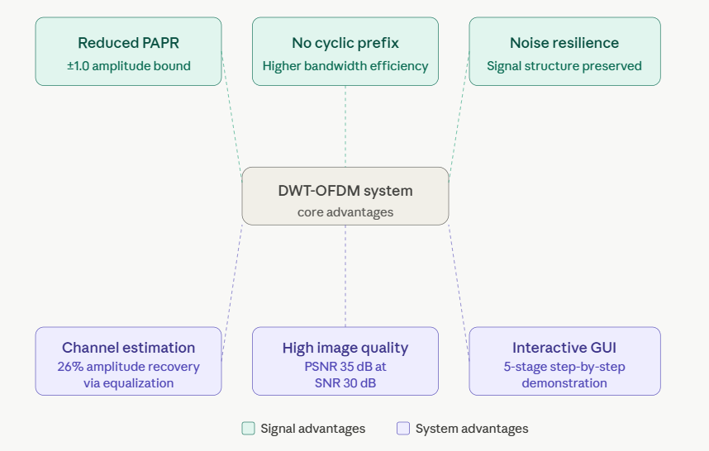
Figure 5.1: Core Advantages of the System
5.4 Limitations of the System
A technically sound analysis of the system involves a frank recognition of the shortcomings that currently exist within the system. Such shortcomings do not negate the successes that have been achieved within the system; they simply determine the parameters of its application at the current time and the precise areas that need to be addressed to ensure its readiness for actual implementation in communication networks.

- Channel Model Simplification:
Perhaps the biggest weakness of the existing system is that it uses the AWGN channel model exclusively in the simulation of wireless channels. The AWGN channel model is one of the simplest channel models to use and is generally accepted by researchers but it only simulates thermal noise.
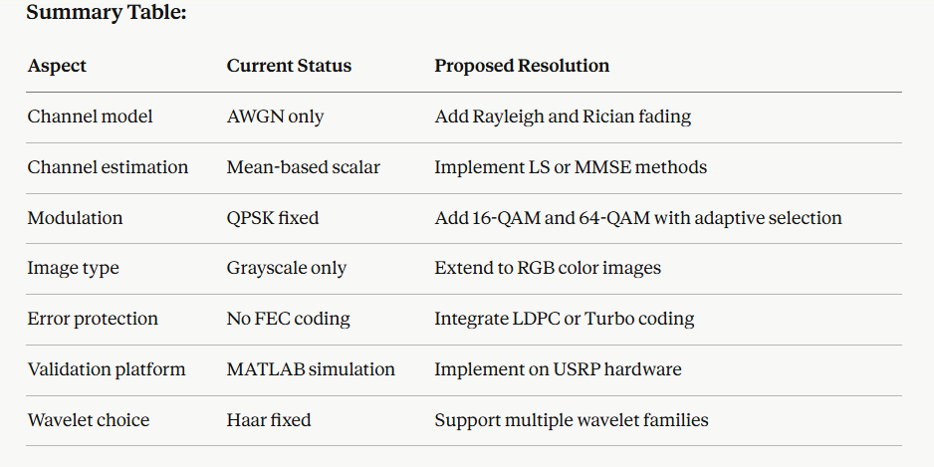
Table 5.1: Channel Model Simplification
Practical wireless channels are significantly more complicated as shown in Table 5.1, taking into account issues like multipath propagation, leading to frequency selective fading, time varying Doppler shift due to motion of either the transmitter or receiver, inter symbol interference due to delayed multipath signals, and co-channel interference from adjacent transmitters. The performance of this system has yet to be studied in any of these realistic channel scenarios, thus limiting the practical applicability of this design.

- Simplified Channel Estimation Approach:
In the case of the mean based channel estimation used in the receiver part of the system, a relatively straightforward estimation of the channel characteristics is obtained, albeit suboptimal from the mathematical point of view. The technique involves computing just one channel parameter (a ratio of the received to transmitted signals), assuming an idealized scenario of the flat non-frequency-selective channel with uniform gain. In reality, wireless channels are known to be frequency-selective and will therefore require individual estimation for each carrier or block instead of one global parameter. With the scalar H_est, the distortion of the original signal caused by the channel effects will remain uncompensated and become apparent as pixel errors in the reconstructed picture.
- Limited Modulation Scheme:
Currently, the system is limited to the use of QPSK modulation that carries two bits per symbol. Although the QPSK technique offers good noise resistance capabilities and is suitable for low-to-medium SNR operations, it hampers the throughput of the system. Since the 128 x 128 pixel image has a total of 131,072 bits, QPSK necessitates the need for 65,536 symbols for the transmission process. More advanced techniques such as 16-QAM and 64-QAM will allow for fewer symbols while carrying the same amount of data.
- Grayscale Image Support Only:
Currently, the algorithm can only be applied to mono-channel image transmission in grayscale format. However, color images are the primary source of visual media today, having three distinct channels that store color information. Thus, color images occupy three times more storage than grayscale images with the same resolution and content size. This algorithm cannot handle color images.
- Absence of Forward Error Correction:
In its present state, the scheme operates without the application of any forward error correction codes. As there is no coding applied, every bit error caused by the AWGN channel becomes a pixel error in the output image and results in the decrease of PSNR value. Due to a high bit error rate at very low SNR values, the picture distortion reaches such a level that the output PSNR can drop down to 8 dB. The use of error correction code in the process of signal transmission will help to eliminate this problem significantly.
- Simulation-Only Validation:
All performance results shown in this project have been achieved through simulation in MATLAB and not through actual physical experimentation using hardware devices. While simulation is very accurate in simulating mathematically the operations in signal processing, it does not take into account the hardware-related challenges that can affect the actual performance of the wireless communication system. Some of these hardware-related limitations include carrier frequency offset between the transmitter and receiver oscillators, timing synchronization errors, nonlinearities introduced by power amplifiers, quantization noise from analog-to-digital conversion, and antenna couplings.
- Haar Wavelet Specificity:
The implementation is done solely by the use of the Haar wavelet function as the DWT basis function. Although the Haar wavelet function is very efficient in terms of computation and allows for perfect reconstruction, the basis functions are discontinuous due to their step-like shape, which causes blocking artifacts in the reconstructed image especially when the SNR is low. Other higher order wavelets like the Daubechies wavelet family can be used to minimize these artifacts but are more computationally intensive.

REFERENCES
[1] P. V. Reddy, K. B. P. Reddy, A. H. Reddy, M. Bangalore, C. N. Reddy, and D. Ganesh, “Advanced Image Steganography System – LSB Algorithm for Secure Data Hiding,” in Proceedings of the 2026 6th International Conference on Image Processing and Capsule Networks (ICIPCN), Dhulikhel, Nepal, 2026, pp. 139– 143, doi: 10.1109/ICIPCN67432.2026.11438506.

[2] F. Gao, X. Deng, C. Gao, and M. Xu, “ULcompress: A Unified Low Bit Rate Image Compression Framework via Invertible Image Representation,” in Proceedings of the 2023 IEEE International Conference on Image Processing (ICIP), Kuala Lumpur, Malaysia, 2023, pp. 2095–2099, doi: 10.1109/ICIP49359.2023.10222242.

[3] J. Yan, Z. Liu, Z. Wang, Y. Fang, and H. Liu, “Towards Scalable and Efficient Full-Reference Omnidirectional Image Quality Assessment,” IEEE Signal Processing Letters, vol. 32, pp. 2459–2463, 2025, doi: 10.1109/LSP.2025.3569458.

[4] L. Xiong, R. Ding, C.-N. Yang, and Z. Fu, “Invertible Secret Image Sharing With Authentication for Embedding Color Palette Image Into True Color Image,” IEEE Transactions on Circuits and Systems for Video Technology, vol. 34, no. 11, pp. 10987– 10999, Nov. 2024, doi: 10.1109/TCSVT.2024.3413024.

[5] L. Ma, J. Yang, Y. Xiang, and M. Chen, “Enhancement of Digital Printing Image Visual Experience Algorithm Based on HSV Color Space,” in Proceedings of the 2023 IEEE 3rd International Conference on Electronic Technology, Communication and Information (ICETCI), Changchun, China, 2023, pp. 850–854, doi: 10.1109/ICETCI57876.2023.10176486.

[6] J. Xu, Y. Xu, Z. Zhu, Z. Hu, S. Hu, and Z. Li, “Research on the Construction and Application of Visual Inspection System for Power Tools Based on Image Recognition Technology,” in Proceedings of the 2024 IEEE 2nd International Conference on Control, Electronics and Computer Technology (ICCECT), Jilin, China, 2024, pp. 1089–1092, doi: 10.1109/ICCECT60629.2024.10545837.

[7] R. Shibata and Y. Yamauchi, “End-to-End Learning Framework Incorporating Image Reconstruction and Recognition Models,” IEEE Access, vol. 13, pp. 73355–73361, 2025, doi: 10.1109/ACCESS.2025.3563476.

[8] O. Dorgham, S. Aburass, and G. F. Issa, “Framework for Enhanced Digital Image Transmission Security: Integrating Hu Moments, Digital Watermarking, and Cryptographic Hashing for Integrity Verification,” in Proceedings of the 2024 2nd International Conference on Cyber Resilience (ICCR), Dubai, UAE, 2024, pp. 1–5, doi: 10.1109/ICCR61006.2024.10532924.

[9] W. Zhang, J. Xu, Y. Chen, D. Li, and W. Gao, “Low-Overhead Compression-Aware Channel Filtering for Hyperspectral Image Compression,” IEEE Geoscience and Remote Sensing Letters, vol. 22, pp. 1–5, 2025, Art. no. 5503805, doi: 10.1109/LGRS.2025.3562933.

[10] J. S and R. Khilar, “Feature-Based Crypto-Imaging Framework for Secure Medical Image Transmission,” in Proceedings of the 2025 6th International Conference on Data Intelligence and Cognitive Informatics (ICDICI), Tirunelveli, India, 2025, pp. 555–561, doi: 10.1109/ICDICI66477.2025.11135048.

[11] R. F. Gusa, R. Hidayat, and H. A. Nugroho, “Speckle Noise Reduction in Ultrasound Images Using Various Denoising Techniques,” in Proceedings of the 2024 International Seminar on Intelligent Technology and Its Applications (ISITIA), Mataram, Indonesia, 2024, pp. 338–342, doi: 10.1109/ISITIA63062.2024.10667756.

[12] J. J. Hephzipah, B. Sarala, M. Perarasi, S. Kowsik, P. ManojKummar, and S. Kogulram, “Road Crack and Road Quality Checking Mechanism,” in Proceedings of the 2023 7th International Conference on Intelligent Computing and Control Systems (ICICCS), Madurai, India, 2023, pp. 882–886, doi: 10.1109/ICICCS56967.2023.10142727.

[13] R. Pucci and N. Martinel, “CE-VAE: Capsule Enhanced Variational AutoEncoder for Underwater Image Enhancement,” in Proceedings of the 2025 IEEE/CVF Winter Conference on Applications of Computer Vision (WACV), Tucson, AZ, USA, 2025, pp. 2113–2123, doi: 10.1109/WACV61041.2025.00212.

[14] S. Munyoro, T. Wu, and W. Zhou, “Dynamic Deep Coding for Secure Image Transmission Over Communication Networks,” in Proceedings of the 2025 13th International Conference on Intelligent Computing and Wireless Optical Communications (ICWOC), Chengdu, China, 2025, pp. 168–173, doi: 10.1109/ICWOC65853.2025.11150788.

[15] G. Tang, L. Duan, H. Zhao, and F. Liu, “A Novel Multi-Stream Fusion Network for Underwater Image Enhancement,” China Communications, vol. 21, no. 2, pp. 166–182, Feb. 2024, doi: 10.23919/JCC.ja.2022-0844.

[16] Y. Yue, Y. Xu, C. Jiang, X. Liu, and D. Ta, “High Spatiotemporal Resolution Ultrasound Imaging Based on Single Plane Wave,” in Proceedings of the 2024 IEEE Ultrasonics, Ferroelectrics, and Frequency Control Joint Symposium (UFFC-JS), Taipei, Taiwan, 2024, pp. 1–4, doi: 10.1109/UFFC JS60046.2024.10793632.

[17] S. Sen, S. Datta, J. Jana, S. Tripathi, and J. Bhaumik, “Hybrid Wavelet Based Image Compression with Zigzag Scanning, RLE, and Huffman Coding,” in Proceedings of the 2025 5th IEEE International Conference on Applied Electromagnetics, Signal Processing, & Communication (AESPC), Bhubaneswar, India, 2025, pp. 1–4, doi: 10.1109/AESPC67542.2025.11326831.

[18] F. Gao, X. Deng, J. Jing, X. Zou, and M. Xu, “Extremely Low BitRate Image Compression via Invertible Image Generation,” IEEE Transactions on Circuits and Systems for Video Technology, vol. 34, no. 8, pp. 6993–7004, Aug. 2024, doi: 10.1109/TCSVT.2023.3317424.

[19] V. U and G. V, “Superpixel Based Image Colorization with Automated Reference Image Selection,” in Proceedings of the 2023 IEEE International Students' Conference on Electrical, Electronics and Computer Science (SCEECS), Bhopal, India, 2023, pp. 1–6, doi: 10.1109/SCEECS57921.2023.10061822.
[20] K. Anand, M. Priyadharshini, and K. Priyadharshini, “Compression and Decompression of Files Without Loss of Quality,” in Proceedings of the 2023 International Conference on Networking and Communications (ICNWC), Chennai, India, 2023, pp. 1–6, doi: 10.1109/ICNWC57852.2023.10127236.







